# Life Cycle Plan (LCP)

**City of Los Angeles**

**Public Safety Applicant Resource Center**

**Team No. 09**

**Team members and roles:**

**Vaibhav Mathur Project Manager**

**Preethi Ramesh Feasibility Analyst**

**Arijit Dey Requirements Engineer**

**Shreyas Devraj Prototyper**

**Gaurav Mathur Builder**

**Divya Nalam OCE**

**Rakesh Mathur IIV&V**

**10/20/2013**

# Version History

| Date | | Author | | | Version | | Changes made | Rationale | | |
| --- | --- | --- | --- | --- | --- | --- | --- | --- | --- | --- |
| 09/26/13 | | Vaibhav Mathur,Arijit Dey, Shreyas Devaraj | 1.0 | | * First Draft of the Life Cycle Plan | | | * To initiate the Life Cycle Planning process and discuss the skills required. |
|  | |  | | |  | |  |  | | |
| 10/12/13 | | Arijit Dey, Shreyas Devaraj | 1.1 | | * Modification done to Section 2, Section 3.1, 4, 5. | | | * First Revision before FC Package. |

|  |  |  |  |  |
| --- | --- | --- | --- | --- |
| 10/20/13 | Arijit Dey, Shreyas Devaraj | 1.2 | * Modification done to Section 3.1, 4, 5. | * First Revision after FC Package which includes the review responses of the stakeholders from ARB session. |

|  |  |  |  |  |
| --- | --- | --- | --- | --- |
| 10/22/13 | Arijit Dey, Shreyas Devaraj | 1.3 | * Modification done to Section 6.1 | * Revision for DC Package. |

# Table of Contents

Life Cycle Plan (LCP) i

Version History ii

Table of Contents iii

Table of Tables iv

Table of Figures 1

1. Introduction 1

2. Milestones and Products 3

3. Responsibilities 5

3.1 Responsibilities by Phase 5

3.2 Skills 7

4. Approach 8

4.1 Monitoring and Control 8

4.2 Methods, Tools and Facilities 8

4.3 Project Plan 8

5. Resources 13

6. Iteration Plan 22

6.1 Plan 22

6.1.1 Capabilities to be implemented 22

6.1.2 Capabilities to be tested 22

6.1.3 Capabilities not to be tested 23

6.1.4 CCD Preparation Plans 23

6.2 Iteration Assessment 23

6.2.1 Capabilities Implemented, Tested, and Results 23

6.2.2 Core Capabilities Drive-Through Results 23

6.3 Adherence to Plan 24

# Table of Tables

Table 1: Stakeholder's responsibilities 5

Table 2: COCOMOII Scale Driver **Error! Bookmark not defined.**

Table 3: COCOMOII Cost Driver **Error! Bookmark not defined.**

Table 4: Module lists and SLOC of each module - example 13

Table 5: COCOMOII Scale Drivers - example 13

Table 6: COCOMOII Cost Drivers of Module 1 - Plant Service Recording module - example 13

Table 7: Construction iteration capabilities to be implemented 22

Table 8: Construction iteration capabilities to be tested 22

Table 9: Capabilities implemented, tested, and results 23

# Table of Figures

Figure 1: COCOMO Estimation Result 21

1. **Introduction**
   1. **Purpose**

The Life Cycle plan helps the stakeholders to get a clear picture of what are the objectives to be achieved, when are the milestones & deadlines and what are the products which needs to be delivered, what are the responsibilities and what should be our approach towards it, what resources we have and what are the assumptions in regard to this project.

* 1. **Status**

The present status of the project is at the foundation phase. This LCP presently contains our future plans, updated responsibilities, and milestones to be encountered in the various phases. Also, an estimation of the project using COINCOMO is attached to analyze the project’s feasibility within 12 weeks.

* 1. **Assumptions**
* The system will be readily accepted by the City of Los Angeles Staff.
* There needs to be no integration with the current Application System.
* There is no integration with data of current manual applicant investigation process.

### Milestones and Products

**Overall Strategy**

The City of Los Angeles Application Resource Center is an online system which built following the architected agile process as we have to develop the project from scratch with minimum COTS involvement.

**Exploration phase**

**Duration:** 09/11/13- 09/26/13

**Concept:** In the Exploration Phase the team was formed and the project was selected. The current system was analyzed. Team held several meetings to discuss on the requirements & initial scope of the project. The team had also held meetings with its stakeholders to clarify their doubts and establish a win-win state. The team also worked on what are the resources, project plan and skills required for the project to be done which are mentioned in the initial artifacts of the VC Package.

**Deliverables**: Client Interaction Report. Valuation Commitment Package which includes Operational Concept Design, Life Cycle Plan and Feasibility Evidence Description.

**Milestone**: Valuation Commitment Review

**Strategy**: One Incremental Commitment Cycle

**Valuation phase**

**Duration:** 09/26/13- 10/16/13

**Concept:** In the Valuation Phase, the team evaluated the win conditions to develop the operational concepts and implemented the prototype to mitigate major risks. The team had developed the initial prototype using the win conditions. The prototype had the following features of generating automated email to the references, and the reference on getting the email had the ability to click on the link, login using his credentials and fill out the background verification questionnaire.

**Deliverables**: Draft Foundation Commitment Package which includes Operational Concept Design, Life Cycle Plan and Feasibility Evidence Description.

**Milestone**: Foundation Commitment Review

**Strategy**: One Incremental Commitment Cycle

**Foundation phase**

**Duration:** 10/16/13- 11/12/13

**Concept:** In the Foundation Phase, the team will lay the foundations of product development. We need to check the interoperability of using NDI component, understand system architecture, design and test cases. Minimal requirement changes needs to be managed and, the highest priority requirements should be developed.

**Deliverables**: Foundation Commitment Package which includes Operational Concept Design, Life Cycle Plan and Feasibility Evidence Description and Draft Development Commitment Package.

**Milestone**: Development Commitment Review

**Strategy**: One Incremental Commitment Cycle

**Development phase**

**Duration:** 11/11/13- 12/02/13

**Concept:** In the Development Phase, the team will develop the system using the architecture and design mentioned in the operational concepts. The system will be integrated using the modules which are thoroughly tested using unit and integration testing. The team also has to prepare for transition plans, test case and train the support staff to maintain the system.

**Deliverables**: Development Commitment Package which includes Operational Concept Design, Life Cycle Plan and Feasibility Evidence Description.

**Milestone**: Transition Readiness Review

**Strategy**: One Incremental Commitment Cycle

### 

Responsibilities

#### Responsibilities by Phase

Table 1: Stakeholder's responsibilities

|  |  |
| --- | --- |
| **Name: Vaibhav Mathur** | |
| **Role: Project Manager** | |
| **Exploration** | Schedule Meetings, Assign Tasks |
| **Valuation** | Plan Project Meeting, Manage Client Interaction, record Project Progress |
| **Foundations** | Coordinating Meetings with team members and clients. |
| **Development-** Construction Iteration | <<responsibilities>> |
| **Development-** Transition Iteration | <<responsibilities>> |

|  |  |
| --- | --- |
| **Name: Arijit Dey** | |
| **Role: Requirements Engineer** | |
| **Exploration** | Understanding Requirements, Life Cycle Planning |
| **Valuation** | Update Life Cycle Plan, Indentify Milestones, Indentify the features to be implemented |
| **Foundations** | Maintaining the Life Cycle Plan and keeping it updated. |
| **Development-** Construction Iteration | <<responsibilities>> |
| **Development-** Transition Iteration | <<responsibilities>> |

|  |  |
| --- | --- |
| **Name: Divya Nalam** | |
| **Role: Operational Concept Engineer** | |
| **Exploration** | Building the Operational Concept Design Report. |
| **Valuation** | Establishing New Operational Concept and Identify the alternative. |
| **Foundations** | Implement necessary changes to the OCD and Identify the operational concepts to be developed |
| **Development-** Construction Iteration | <<responsibilities>> |
| **Development-** Transition Iteration | <<responsibilities>> |

|  |  |
| --- | --- |
| **Name: Preeti Ramesh** | |
| **Role: Feasibility Analyst** | |
| **Exploration** | Checking for Feasibility Evidence and COTS |
| **Valuation** | Evaluate NDI and interoperability, Mitigation of Risks |
| **Foundations** | Implement necessary changed in the FED, update risks and recalculate ROI. |
| **Development-** Construction Iteration | <<responsibilities>> |
| **Development-** Transition Iteration | <<responsibilities>> |

|  |  |
| --- | --- |
| **Name: Shreyas Devaraj** | |
| **Role: Prototyper** | |
| **Exploration** | Project Plan and Progress Report Maintaining |
| **Valuation** | Develop the prototype based on top priority requirements & risks. |
| **Foundations** | Analyze the win conditions to be implemented, Assist in Life Cycle planning |
| **Development-** Construction Iteration | <<responsibilities>> |
| **Development-** Transition Iteration | <<responsibilities>> |

|  |  |
| --- | --- |
| **Name: Gaurav Mathur** | |
| **Role: Builder** | |
| **Exploration** | Building and maintaining Project Website |
| **Valuation** | Develop the proposed system using the Architecture. |
| **Foundations** | Laying the foundation of development and maintaining Project Website |
| **Development-** Construction Iteration | <<responsibilities>> |
| **Development-** Transition Iteration | <<responsibilities>> |

|  |  |
| --- | --- |
| **Name: Rakesh Mathur** | |
| **Role: IIV & V** | |
| **Exploration** | Validation and Verification of COTS Interoperability |
| **Valuation** | Analyze Business Cases to Validate the work product, Maintain Bugzilla. |
| **Foundations** | Assist to maintain FED, Maintain Bugzilla, Evaluating the development. |
| **Development-** Construction Iteration | <<responsibilities>> |
| **Development-** Transition Iteration | <<responsibilities>> |

#### Skills

|  |  |  |
| --- | --- | --- |
| **Team members** | **Role** | **Skills** |
| Vaibhav Mathur | Project Manager  Life Cycle Planner | Current- ASP.Net, C#, Javascript |
| Arijit Dey | Requirements Engineer  Prototyper | Current- JAVA, Oracle 10g, Visual Basic, HTML, UML.  Required- C#, MySQL |
| Shreyas Devaraj | Prototyper  Project Manager | Current- JAVA, MySQL, JavaScript  Required- ASP.Net, C# |
| Gaurav Mathur | Builder  UML designer | Current-JAVA, C++,MySQL  Required-C# |
| Preethi Ramesh | Feasibility Analyst  Requirement Engineer | Current-ASP.Net, C# |
| Divya Nalam | Operational Concept Engineer  UML designer | Current-C/C++, Python  Required- ASP.Net, C# |
| Rakesh Mathur | Validation and Verification of COTS Interoperability | Current- ASP.Net, C#, JavaScript |

Note:- None of the team members are planning to continue to take up CSCI 577B.

**SKILLS REQUIRED FOR TEAM MEMBERS IN CSCI 577B**

* C#
* ASP.NET
* MYSQL SERVER 2008
* DB2

Approach

#### Monitoring and Control

The team members meet up every week and organize meetings to discuss the project development. The development and project progress are recorded in the Progress Report which is submitted on a biweekly basis. The project report includes lines of code developed, issues, concerns, risk and mitigation plans for the coming week, as well the work done in the previous week. We plan the tasks for the future weeks as well. The tasks are issued to all the team members and monitored using Bugzilla.

Microsoft Project is used to monitor the project plan and track the project progress using the schedule. The project plan includes what all activities are complete, what all tasks to be done and about client and team meeting. Initial issues and deviations are communicated through email and verbally. All the team members are individually accountable for their contributions to the Life Cycle Plan.

##### Closed Loop Feedback Control

The team exchanges feedback using emails and discuss critical issues in the meetings. Bugzilla tickets are also raised to record and track defects and bugs. This allows all the team members to view, track and finally decide on any open issue. Weekly team meetings and after class mini-team sessions is also conducted. Minutes and agendas of the meetings are recorded for being referred to later.

##### Reviews

Weekly team meetings are organized to discuss and review documents and issues. The author of an artifact or document emails it to the rest of the member for review and updating.

#### Methods, Tools and Facilities

|  |  |  |
| --- | --- | --- |
| **Tools** | **Usage** | **Provider** |
| VISUAL STUDIO | Used for development of the project. | MICROSOFT |
| SQL SERVER 2008 | Used as Database for developing Prototype. | MICROSOFT |
| DB2 | Used as Database for developing Project. | IBM |
| ASP.NET | Framework used to develop the Project. | MICROSOFT |
| WHATSAPP | Used to communicate minute information between team member. | WHATSAPP |

#### 4.3 Project Plan

A biweekly project plan is followed to keep track of the project’s progress, schedule and future plans.

The following is our updated project plan as of now.

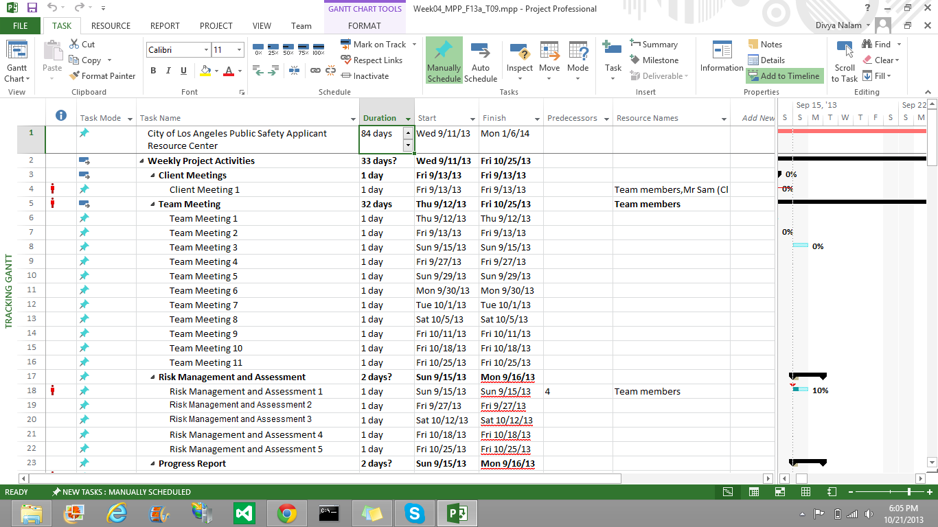

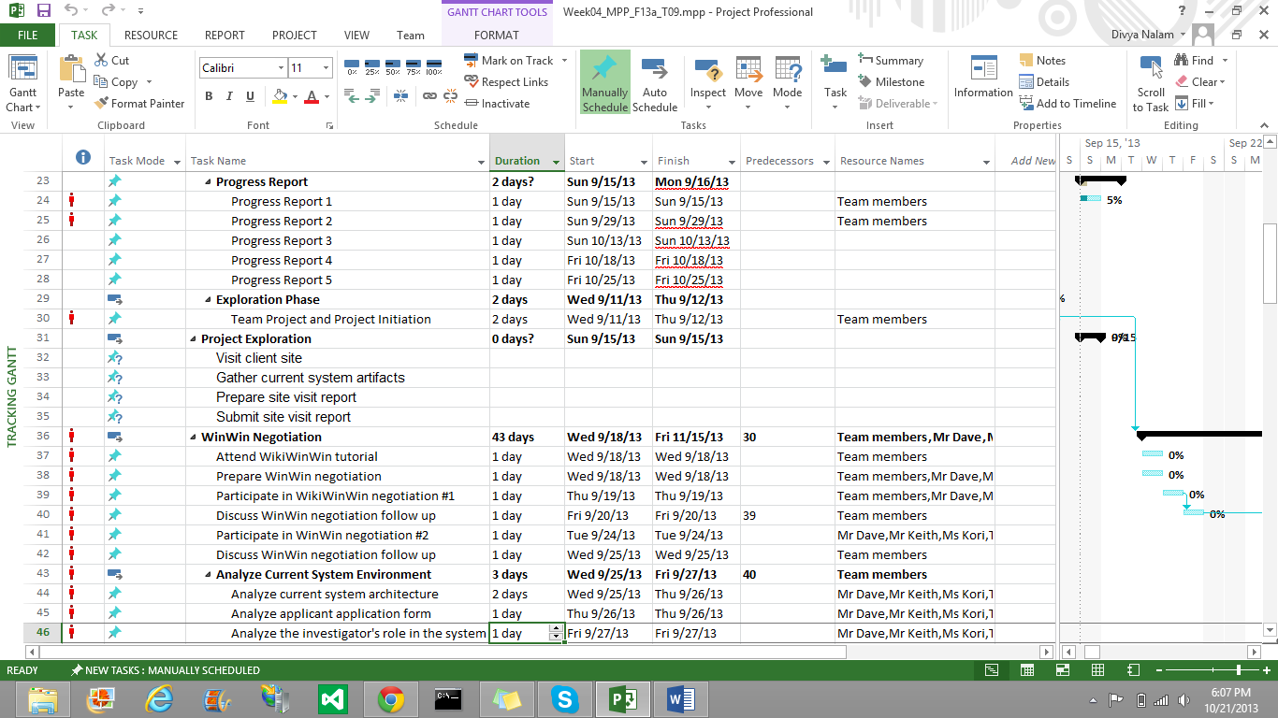

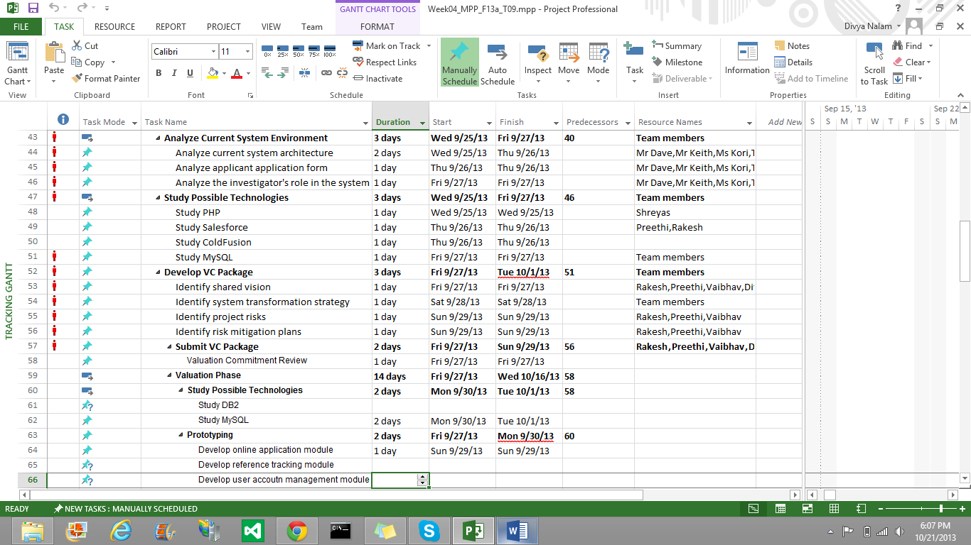

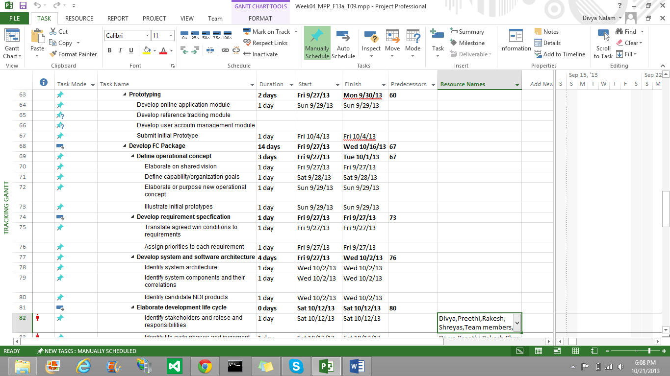

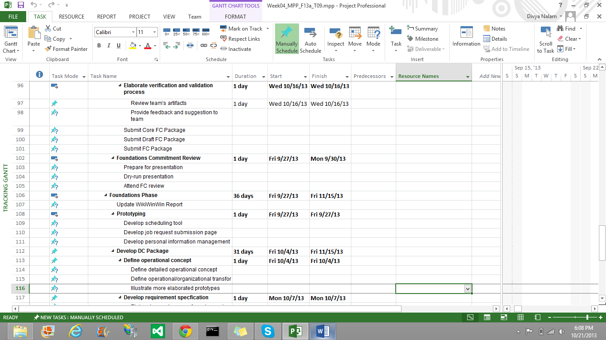

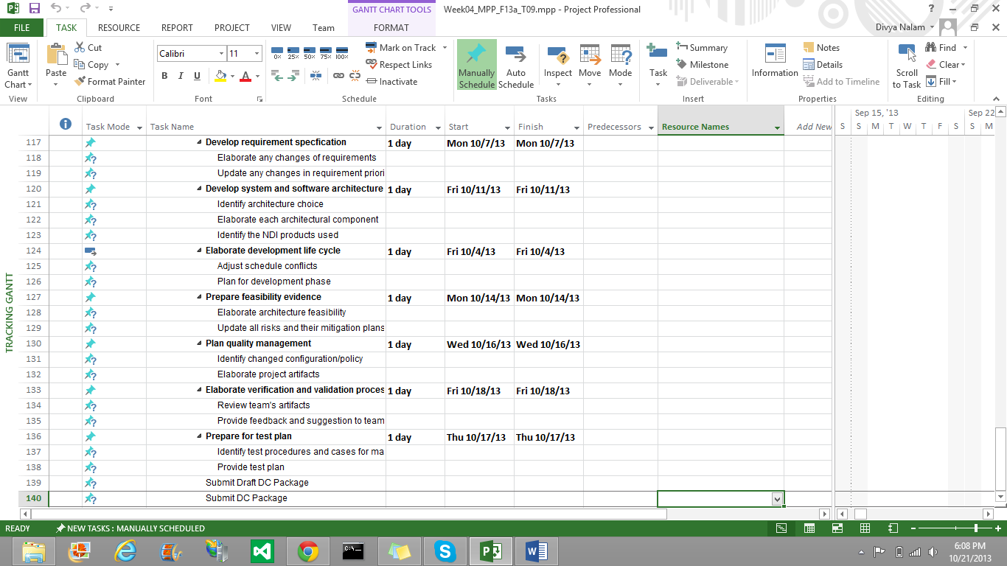

#### 

### Resources

The following is module listed in the system and its estimated size with Source Lines of Code (SLOC)

Table 2: Module lists and SLOC of each module

|  |  |  |  |  |
| --- | --- | --- | --- | --- |
| **No.** | **Module Name** | **Brief Description** | **SLOC** | **REVL** |
| 1 | Login Functionality | Login to the system to access it. | 200 | 8% |
| 2 | Support Staff module | Enter applicant details and add references | 600 | 8% |
| 3 | Investigator Module | View list of applicants, references and responses | 800 | 5% |
| 4 | Reference Module | Ability to login and fill up the reference form | 300 | 5% |
| 5 | Manager Module | Check applicants, investigators and support staff | 1000 | 8% |
| 6 | Email Generation | Generate automated emails to the references. | 200 | 5% |

The following is COCOMOII Scale Drivers and rationales of choosing the values.

Table 3: COCOMOII Scale Drivers

|  |  |  |
| --- | --- | --- |
| **Scale Driver** | **Value** | **Rationale** |
| PREC | HIGH | The development team is familiar with this type of online application. |
| FLEX | NOMINAL | The system needs to conform the requirements specified by the client with some relaxation. |
| RESL | HIGH | By identifying the risk items we can conclude that there exists some uncertainty. |
| TEAM | HIGH | Each stakeholder synchronizes very well with each other and maintain considerable consistency of objectives. |
| PMAT | NOMINAL | The development team follows CMM Level 2 process maturity model. |

The following is COCOMOII Cost Drivers of each module and rationales of choosing the values.

Table 4: COCOMOII Cost Drivers of Module -1 - Login Functionality

|  |  |  |
| --- | --- | --- |
| **Cost Driver** | **Value** | **Rationale** |
| RELY | NOMINAL | If the system fails, it will cause inconvenience to the references and background investigators. But the system can be recovered within certain period of time. |
| DATA | HIGH | The ratio of bytes in the testing database to SLOC in the program is approximately less than 1000 because the database will store all information of candidate’s reference, references’ response which contains lot of data and candidates assigned to investigators. |
| DOCU | NOMINAL | Because the development process follows ICSM, the document for life-cycle needs is normal. |
| CPLX | HIGH | Few modules like authentication using LDAP, implementing manager module, investigator module requires complex programming. |
| RUSE | NOMINAL | The system is used by every department of the background verification organization and also used by the references. |
| TIME | HIGH | The percentage of available execution time expected to be used by the system and subsystem consuming the execution time resource is about 70% because this system is performing the database operation whenever any process is executed. |
| STOR | HIGH | The percentage of available storage expected to be used by the system and subsystem is about 70% because the most of the candidates’ data is stored in the database. And this is used in every database operation. |
| PVOL | LOW | Major changes of the platform, i.e. ASP.net, DB2 and web browsers are approximately every year. |
| ACAP | HIGH | The analysts have good ability to analyze, design and communicate among others. |
| PCAP | HIGH | Programmers are capable, efficient and thorough. Although some of the team members lack knowledge about ASP.net and DB2. |
| PCON | LOW | Our team has 6 members and most of them do not plan to continue in CSCI577B. |
| APEX | NOMINAL | The average experience of the team members for this online web-based application is about one year. |
| LTEX | LOW | The development team plans to develop this web-based application with ASP.net, C# and DB2 language to query information from the database. The tools for programming are Microsoft Visual Studio. Therefore, the language and tool experience is low because only a few team members have at least one year experience with these languages and tools and rest are trying to learn. |
| PLEX | LOW | Most of the team members are inexperienced with ASP.net framework and database as DB2. |
| TOOL | LOW | The software tools development team plan to use is just simple, frontend and backend DB2. |
| SITE | VERY HIGH | In CSCI577a, six of seven team members are on-campus students. Additionally, we use wideband electronic communication and occasional video conference. |
| SCED | NOMINAL | The schedule is fixed for 12 weeks in Fall semester. |
|  |  |  |

Table 7: COCOMOII Cost Drivers of Module - 2 - Support Staff module

|  |  |  |
| --- | --- | --- |
| **Cost Driver** | **Value** | **Rationale** |
| RELY | NOMINAL | If the system fails, it will cause inconvenience to the references and background investigators. But the system can be recovered within certain period of time. |
| DATA | HIGH | The ratio of bytes in the testing database to SLOC in the program is approximately less than 1000 because the database will store all information of candidate’s reference, references’ response which contains lot of data and candidates assigned to investigators. |
| DOCU | NOMINAL | Because the development process follows ICSM, the document for life-cycle needs is normal. |
| CPLX | HIGH | Few modules like authentication using LDAP, implementing manager module, investigator module requires complex programming. |
| RUSE | NOMINAL | The system is used by every department of the background verification organization and also used by the references. |
| TIME | HIGH | The percentage of available execution time expected to be used by the system and subsystem consuming the execution time resource is about 70% because this system is performing the database operation whenever any process is executed. |
| STOR | HIGH | The percentage of available storage expected to be used by the system and subsystem is about 70% because the most of the candidates’ data is stored in the database. And this is used in every database operation. |
| PVOL | LOW | Major changes of the platform, i.e. ASP.net, DB2 and web browsers are approximately every year. |
| ACAP | HIGH | The analysts have good ability to analyze, design and communicate among others. |
| PCAP | HIGH | Programmers are capable, efficient and thorough. Although some of the team members lack knowledge about ASP.net and DB2. |
| PCON | LOW | Our team has 6 members and most of them do not plan to continue in CSCI577B. |
| APEX | NOMINAL | The average experience of the team members for this online web-based application is about one year. |
| LTEX | LOW | The development team plans to develop this web-based application with ASP.net, C# and DB2 language to query information from the database. The tools for programming are Microsoft Visual Studio. Therefore, the language and tool experience is low because only a few team members have at least one year experience with these languages and tools and rest are trying to learn. |
| PLEX | LOW | Most of the team members are inexperienced with ASP.net framework and database as DB2. |
| TOOL | LOW | The software tools development team plan to use is just simple, frontend and backend DB2. |
| SITE | VERY HIGH | In CSCI577a, six of seven team members are on-campus students. Additionally, we use wideband electronic communication and occasional video conference. |
| SCED | NOMINAL | The schedule is fixed for 12 weeks in Fall semester. |

Table 8: COCOMOII Cost Drivers of Module - 3 - Investigator Module

|  |  |  |
| --- | --- | --- |
| **Cost Driver** | **Value** | **Rationale** |
| RELY | NOMINAL | If the system fails, it will cause inconvenience to the references and background investigators. But the system can be recovered within certain period of time. |
| DATA | LOW | The ratio of bytes in the testing database to SLOC in the program is approximately less than 1000 because the database will store all information of candidate’s reference, references’ response which contains lot of data and candidates assigned to investigators. |
| DOCU | NOMINAL | Because the development process follows ICSM, the document for life-cycle needs is normal. |
| CPLX | HIGH | Few modules like authentication using LDAP, implementing manager module, investigator module requires complex programming. |
| RUSE | NOMINAL | The system is used by every department of the background verification organization and also used by the references. |
| TIME | HIGH | The percentage of available execution time expected to be used by the system and subsystem consuming the execution time resource is about 70% because this system is performing the database operation whenever any process is executed. |
| STOR | NOMINAL | The percentage of available storage expected to be used by the system and subsystem is about 70% because the most of the candidates’ data is stored in the database. And this is used in every database operation. |
| PVOL | LOW | Major changes of the platform, i.e. ASP.net, DB2 and web browsers are approximately every year. |
| ACAP | HIGH | The analysts have good ability to analyze, design and communicate among others. |
| PCAP | HIGH | Programmers are capable, efficient and thorough. Although some of the team members lack knowledge about ASP.net and DB2. |
| PCON | LOW | Our team has 6 members and most of them do not plan to continue in CSCI577B. |
| APEX | NOMINAL | The average experience of the team members for this online web-based application is about one year. |
| LTEX | LOW | The development team plans to develop this web-based application with ASP.net, C# and DB2 language to query information from the database. The tools for programming are Microsoft Visual Studio. Therefore, the language and tool experience is low because only a few team members have at least one year experience with these languages and tools and rest are trying to learn. |
| PLEX | LOW | Most of the team members are inexperienced with ASP.net framework and database as DB2. |
| TOOL | LOW | The software tools development team plan to use is just simple, frontend and backend DB2. |
| SITE | VERY HIGH | In CSCI577a, six of seven team members are on-campus students. Additionally, we use wideband electronic communication and occasional video conference. |
| SCED | NOMINAL | The schedule is fixed for 12 weeks in Fall semester. |

Table 9: COCOMOII Cost Drivers of Module - 4 - Reference Module

|  |  |  |
| --- | --- | --- |
| **Cost Driver** | **Value** | **Rationale** |
| RELY | VERY HIGH | If the system fails, it will cause inconvenience to the references and background investigators. But the system can be recovered within certain period of time. |
| DATA | HIGH | The ratio of bytes in the testing database to SLOC in the program is approximately less than 1000 because the database will store all information of candidate’s reference, references’ response which contains lot of data and candidates assigned to investigators. |
| DOCU | NOMINAL | Because the development process follows ICSM, the document for life-cycle needs is normal. |
| CPLX | HIGH | Few modules like authentication using LDAP, implementing manager module, investigator module requires complex programming. |
| RUSE | NOMINAL | The system is used by every department of the background verification organization and also used by the references. |
| TIME | HIGH | The percentage of available execution time expected to be used by the system and subsystem consuming the execution time resource is about 70% because this system is performing the database operation whenever any process is executed. |
| STOR | HIGH | The percentage of available storage expected to be used by the system and subsystem is about 70% because the most of the candidates’ data is stored in the database. And this is used in every database operation. |
| PVOL | LOW | Major changes of the platform, i.e. ASP.net, DB2 and web browsers are approximately every year. |
| ACAP | HIGH | The analysts have good ability to analyze, design and communicate among others. |
| PCAP | HIGH | Programmers are capable, efficient and thorough. Although some of the team members lack knowledge about ASP.net and DB2. |
| PCON | LOW | Our team has 6 members and most of them do not plan to continue in CSCI577B. |
| APEX | NOMINAL | The average experience of the team members for this online web-based application is about one year. |
| LTEX | LOW | The development team plans to develop this web-based application with ASP.net, C# and DB2 language to query information from the database. The tools for programming are Microsoft Visual Studio. Therefore, the language and tool experience is low because only a few team members have at least one year experience with these languages and tools and rest are trying to learn. |
| PLEX | LOW | Most of the team members are inexperienced with ASP.net framework and database as DB2. |
| TOOL | LOW | The software tools development team plan to use is just simple, frontend and backend DB2. |
| SITE | VERY HIGH | In CSCI577a, six of seven team members are on-campus students. Additionally, we use wideband electronic communication and occasional video conference. |
| SCED | NOMINAL | The schedule is fixed for 12 weeks in Fall semester. |

Table 10: COCOMOII Cost Drivers of Module - 5 - Manager Module

|  |  |  |
| --- | --- | --- |
| **Cost Driver** | **Value** | **Rationale** |
| RELY | NOMINAL | If the system fails, it will cause inconvenience to the references and background investigators. But the system can be recovered within certain period of time. |
| DATA | HIGH | The ratio of bytes in the testing database to SLOC in the program is approximately less than 1000 because the database will store all information of candidate’s reference, references’ response which contains lot of data and candidates assigned to investigators. |
| DOCU | NOMINAL | Because the development process follows ICSM, the document for life-cycle needs is normal. |
| CPLX | HIGH | Few modules like authentication using LDAP, implementing manager module, investigator module requires complex programming. |
| RUSE | NOMINAL | The system is used by every department of the background verification organization and also used by the references. |
| TIME | HIGH | The percentage of available execution time expected to be used by the system and subsystem consuming the execution time resource is about 70% because this system is performing the database operation whenever any process is executed. |
| STOR | HIGH | The percentage of available storage expected to be used by the system and subsystem is about 70% because the most of the candidates’ data is stored in the database. And this is used in every database operation. |
| PVOL | LOW | Major changes of the platform, i.e. ASP.net, DB2 and web browsers are approximately every year. |
| ACAP | HIGH | The analysts have good ability to analyze, design and communicate among others. |
| PCAP | HIGH | Programmers are capable, efficient and thorough. Although some of the team members lack knowledge about ASP.net and DB2. |
| PCON | LOW | Our team has 6 members and most of them do not plan to continue in CSCI577B. |
| APEX | NOMINAL | The average experience of the team members for this online web-based application is about one year. |
| LTEX | LOW | The development team plans to develop this web-based application with ASP.net, C# and DB2 language to query information from the database. The tools for programming are Microsoft Visual Studio. Therefore, the language and tool experience is low because only a few team members have at least one year experience with these languages and tools and rest are trying to learn. |
| PLEX | LOW | Most of the team members are inexperienced with ASP.net framework and database as DB2. |
| TOOL | LOW | The software tools development team plan to use is just simple, frontend and backend DB2. |
| SITE | VERY HIGH | In CSCI577a, six of seven team members are on-campus students. Additionally, we use wideband electronic communication and occasional video conference. |
| SCED | NOMINAL | The schedule is fixed for 12 weeks in Fall semester. |

Table 11: COCOMOII Cost Drivers of Module - 6 – Email generation

|  |  |  |
| --- | --- | --- |
| **Cost Driver** | **Value** | **Rationale** |
| RELY | LOW | If the system fails, it will cause inconvenience to the references and background investigators. But the system can be recovered within certain period of time. |
| DATA | LOW | The ratio of bytes in the testing database to SLOC in the program is approximately less than 1000 because the database will store all information of candidate’s reference, references’ response which contains lot of data and candidates assigned to investigators. |
| DOCU | NOMINAL | Because the development process follows ICSM, the document for life-cycle needs is normal. |
| CPLX | NOMINAL | Few modules like authentication using LDAP, implementing manager module, investigator module requires complex programming. |
| RUSE | NOMINAL | The system is used by every department of the background verification organization and also used by the references. |
| TIME | HIGH | The percentage of available execution time expected to be used by the system and subsystem consuming the execution time resource is about 70% because this system is performing the database operation whenever any process is executed. |
| STOR | NOMINAL | The percentage of available storage expected to be used by the system and subsystem is about 70% because the most of the candidates’ data is stored in the database. And this is used in every database operation. |
| PVOL | LOW | Major changes of the platform, i.e. ASP.net, DB2 and web browsers are approximately every year. |
| ACAP | HIGH | The analysts have good ability to analyze, design and communicate among others. |
| PCAP | HIGH | Programmers are capable, efficient and thorough. Although some of the team members lack knowledge about ASP.net and DB2. |
| PCON | LOW | Our team has 6 members and most of them do not plan to continue in CSCI577B. |
| APEX | NOMINAL | The average experience of the team members for this online web-based application is about one year. |
| LTEX | LOW | The development team plans to develop this web-based application with ASP.net, C# and DB2 language to query information from the database. The tools for programming are Microsoft Visual Studio. Therefore, the language and tool experience is low because only a few team members have at least one year experience with these languages and tools and rest are trying to learn. |
| PLEX | LOW | Most of the team members are inexperienced with ASP.net framework and database as DB2. |
| TOOL | LOW | The software tools development team plan to use is just simple, frontend and backend DB2. |
| SITE | VERY HIGH | In CSCI577a, six of seven team members are on-campus students. Additionally, we use wideband electronic communication and occasional video conference. |
| SCED | NOMINAL | The schedule is fixed for 12 weeks in Fall semester. |

The following is the result from COCOMOII estimation based on Scale Drivers and Cost Drivers discussed above.

Figure 1: COCOMO Estimation Result

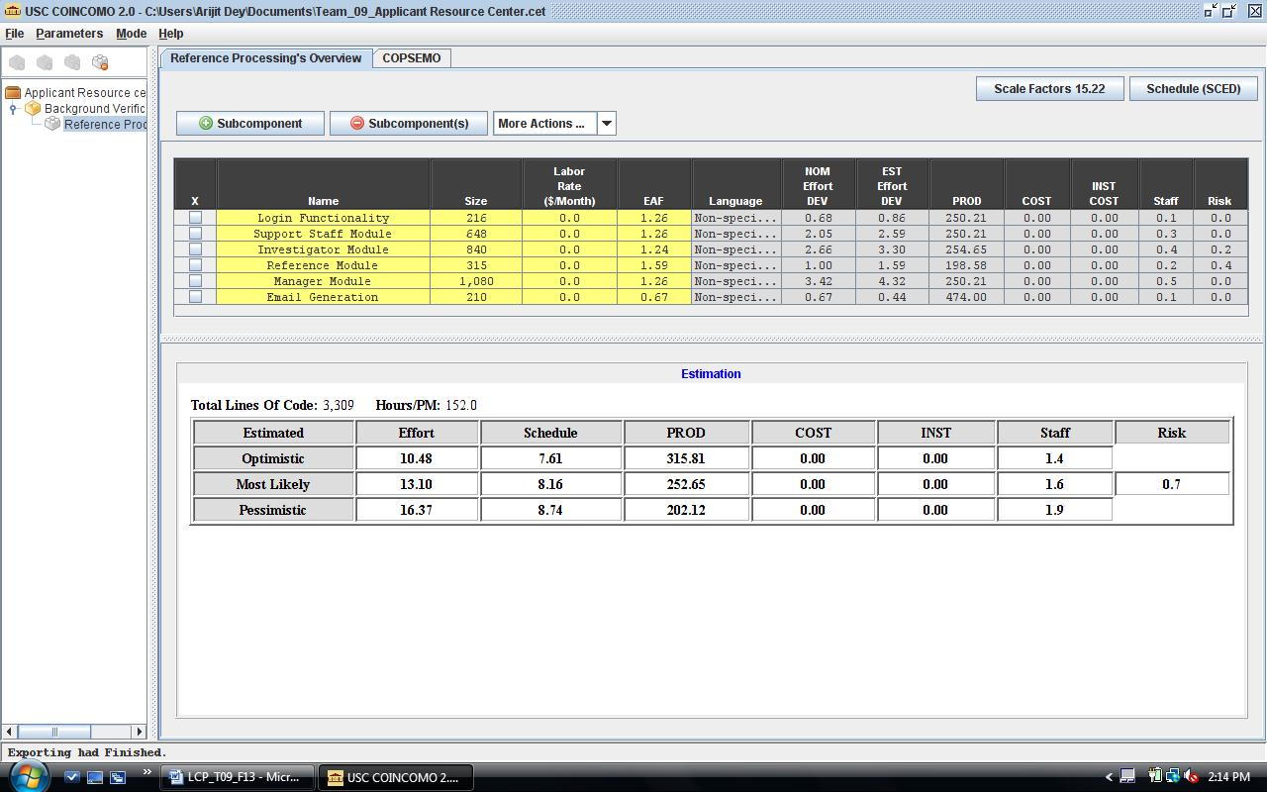

The form of schedule our project uses is the Independent Variable (SAIV) strategy; 12–week schedule drives development of a set of top priority core capabilities. Therefore, the estimates show the effort required for the project.

According to COCOMO II Estimates for CSCI577, one team member effort = 1.67 COCOMO II person months. The total effort put forward by a team of 7 members is 7*1.67=11.69 person months, which is less than the most likely effort. The pessimistic effort from the COCOMO estimation above is 16.37, so the total team members need for this project = 16.37/1.67 = 8.6

Since, we have 7 people, from this effort estimation; we would not be able to finish the project completely in one semester.

As of now, we should focus on the core features and get back to the low priority features, if time permits.

# 6. Iteration Plan

## 6.1 Plan

After laying the foundations of development in the foundations phase, we now plan for the iterations to be executed in the development phase. The first iteration consists of the development of the core functionalities of the application resource center. Following it, we will test the functionalities and will do a drive through to check for user experience. Next iteration will consist of developing the low priority features.

### 6.1.1 Capabilities to be implemented

Below are the capabilities which our team plans to develop in the development phase. The priorities of each capability are different and implemented according to it.

Table 5: Construction iteration capabilities to be implemented

|  |  |  |  |  |
| --- | --- | --- | --- | --- |
| ID | Capability | Description | Priority | Iteration |
| 1 | Email Generation | Automated Email generation to references | HIGH | 1 |
| 2 | Reference Letter | Reference Letter Completion | HIGH | 1 |
| 3 | Review | Reference Review | HIGH | 1 |
| 4 | Resend Email | Reminder Sending | MEDIUM | 2 |
| 5 | Manger | Manager Reviews | MEDIUM | 2 |
| 6 | Investigator | Assignment of investigators | MEDIUM | 2 |
| 7 | Updating | Investigator Update | LOW | 3 |

### 6.1.2 Capabilities to be tested

Below are the capabilities which are to be tested in the development phase. The testing will be initially done by the developers, followed by testing by all the team members and lastly the system needs to be tested by the clients and users.

Table 6: Construction iteration capabilities to be tested

|  |  |  |  |  |
| --- | --- | --- | --- | --- |
| ID | Capability | Description | Priority | Iteration |
| 1 | Email Generation | Automated Email generation to references | HIGH | 3 |
| 2 | Reference Letter | Reference Letter Completion | HIGH | 3 |
| 3 | Review | Reference Review | HIGH | 3 |

### 6.1.3 Capabilities not to be tested

Almost all the capabilities of our system need to be tested. There does not exist any such capability which need not be tested.

### 6.1.4 CCD Preparation Plans

The system will be tested by David Lubeley, Kori Parraga, and other members of the City of Los Angeles public safety department for the entry of applicant and reference details, automated email generation and reference form filling. The system will be tested in different environment to check for the website’s performance using different web browsers and real time data which will be provided by the client.

## 6.2 Iteration Assessment

### 6.2.1 Capabilities Implemented, Tested, and Results

<< Describes, in brief, the capabilities that were implemented and the test results. The capabilities implemented and tested do not necessarily need to match the ones listed in section 6.1 because some capabilities may have been pushed to the next iteration. >>

Table 7: Capabilities implemented, tested, and results

|  |  |  |  |  |
| --- | --- | --- | --- | --- |
| **ID** | **Capability** | **Test Case** | **Test Results** | **If fail, why?** |
| < ID > | < Capability > | < TC-XX **>** | Pass/Fail | < comments > |
| … |  |  |  |  |

### 6.2.2 Core Capabilities Drive-Through Results

<< Briefly summarize the feedback you received from your client(s). You need to be specific enough to cover the critical capabilities or scenarios that were discussed, demoed, or shown. Your descriptions MUST, but not limited to, cover the following areas:

* Positive feedbacks
* Improvements needed/suggested
* Changes to‐be considered (Reprioritized capabilities, requirements, GUI, etc.)
* Risks (New risks introduced, risks mitigated, etc.)

Note: Make sure to be specific to the capabilities shown/demonstrated/driven-through.

Simply stating that the clients liked the capabilities is not sufficient. >>

## 6.3 Adherence to Plan

<< Describe how well the iteration ran according to plan. Was it on budget and on time? Is there any uncertainty in the Software Development Status? Provide some insight to avoid mistakes for future iterations. >>